AUTHORIZATION FOR TREATMENT

EMPLOYEE NAME: SS#
COMPANY NAME: Skyline Property Group _____________________________________________________________________
COMPANY PHONE # (317) 865-8818 FAX #
Company Representative Authorizing Treatment (print name):
Company Representative Authorizing Treatment (e-mail): Company Representative Signature: Phone # The above employee is scheduled on: Date: Time:

Check Appropriate Clinic
(See reverse side for clinic maps)

Franciscan WorkingWell locations: Choose one of these locations for your employee’s occupational health needs.
CityWay 325 S. Alabama St., Suite 100, Indianapolis, IN 46204, Tel (317) 705-4785, Fax (317) 705-4798
Greenwood 747 E. County Line Rd., Greenwood, IN 46143, Tel (317) 528-8009, Toll Free (877) 516-5777, Fax (317) 528-8012
Mooresville 1215 Hadley Rd., Suite 205 Mooresville, IN 46158, Tel (317) 834-5220, Fax (317) 834-5229
Carmel 10767 Illinois St., Suite 1300, Carmel, IN 46032, Tel (317) 528-2777, Fax (317) 528-2778

Franciscan ExpressCare locations: Choose one of these when the WorkingWell locations are closed and on weekends.
Stones Crossing 1703 W. Stones Crossing, Greenwood, IN 46143, Tel (317) 528-2141
Greenwood 1001 N. Madison Ave., Greenwood, IN 46142, Tel (317) 528-7500
Thompson Commons 5210 E. Thompson Rd., Indianapolis, IN 46237, Tel (317) 782-7500
CityWay 325 S. Alabama Street, Suite 100, Indianapolis, IN 46204, Tel (317) 705-4785
Carmel 10767 Illinois St., Suite 1300, Carmel, IN 46032, Tel (317) 528-2777, Fax (317) 528-2778

Check Services Needed

Diagnosis & Treatment Physical Examination
Injury Treatment DOT Non-DOT

Pre-placement

Other:

Check Type of Drug Testing Needed
Non-DOT Urine Drug Screen (Chain of Custody) DOT Urine Drug Screen (Chain of Custody) Instant Urine Drug Screen (5-panel E-Cup)

Instant Urine Drug Screen (10-panel) Other:

Collection Only Urine Drug Screen
Breath Alcohol Non-DOT
Non-DOT DOT
DOT
Laboratory:

Hair Analysis Other:

Check Reason For Drug Test
Reasonable Suspicion / Cause (Select one of the following: Post Accident, Injury or Other)

Pre-Placement
Random
Post-Accident
Post-Injury
Other:

Check Any Additional Services Needed
(Note: Call for availability.)

Respirator Questionnaire Respirator Fit Testing
Spirometry Testing Audiometric Exams
Wellness Screenings Vaccinations
Lift Evaluations

Other:
Time:
Date:
INTERNAL USE ONLY Verbal Authorization from:
WW Signature:

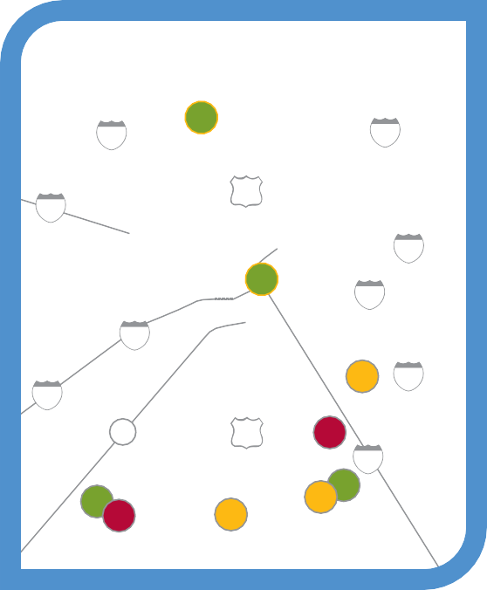4
65 Carmel ⁶⁹

PROVIDING CARE FOR YOUR EMPLOYEES 24 HOURS A DAY
74
INDIANAPOLIS

31

CityWay
1

70

465

Walk-In Injury Care is Always Available

Occupational Health is our expertise

465

70

67

7 74

31 8

Immediate triage available for injuries
- Comprehensive return-to-work strategies

Mooresville
3

65
Stones Crossing 6 2

Rapid drug screening available
- Case Management services available
Indiana St.
Indianapolis Rd.
9 5 Greenwood

CityWay (Located with Franciscan ExpressCare)
Franciscan Working Well Greenwood
2
Southport Rd.

Stop 11 Rd.

County Line Rd.
Fry Rd.
GREENWOOD
South St.
McCarty
INDIANAPOLIS
1
Franciscan Working Well & ExpressCare CityWay
Emerson Ave.
Meridian St.
Delaware St.
Alabama St.
East St.
325 S. Alabama Street, Suite 100
Indianapolis, IN 46204, (317) 705-4785 M – F, 8 a.m. to 8 p.m.
Sat – Sun, 10 a.m. to 6 p.m.
Greenwood
747 E. County Line Rd.
267
Bridge St.
MOORESVILLE
Main St.
High St.
67
Hadley Rd.
42
67
144
3
Franciscan Working Well Mooresville
CARMEL
4
Franciscan Working Well & ExpressCare Carmel
Johnson Rd.
N Illinois St.
Greenwood, IN 46143, (317) 528-8009
M – F, 7 a.m. to 7 p.m.
Mooresville
1215 Hadley Rd., Suite 205
Mooresville, IN 46158, (317) 834-5220
M – F, 8 a.m. to 5 p.m.
Carmel
10767 Illinois St., Suite 1300
Carmel, IN 46032, (317) 528-2778

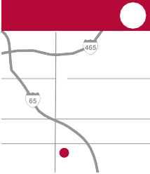For non-emergency after-hours injury care, visit the Franciscan ExpressCare locations (marked on the map in yellow). For emergency after-hours injury care, visit the emergency room (marked on the map in red).
Franciscan ExpressCare Indianapolis
7
Thompson Rd.

Southport Rd. Stop 11 Rd.
Franciscan ExpressCare Stones Crossing
5
County Rd. 700 N.
Franciscan ExpressCare Greenwood
6
Southport Rd.
County Line Rd.
Fry Rd.

Smith Valley Rd.
Franciscan Emergency Room Indianapolis
8
Southport Rd.

Stop 11 Rd.
Franciscan Emergency Room Mooresville
9
Hadley Rd.
Indiana St.
Emerson Ave.

1703 W. Stones Crossing Greenwood, IN 46143 (317)
Honey Creek Rd.
528-2141
M – F, 8 a.m. to 8 p.m.
Sat – Sun, 10 a.m. to 6 p.m.
1001 N. Madison Ave. Greenwood, IN 46142
(317) 528-7500
Daily, 8 a.m. to 8 p.m.
5210 E. Thompson Rd. Indianapolis, IN 46237
(317) 782-7500
Emerson Ave.
Daily, 8 a.m. to 8 p.m.
8111 S. Emerson Ave. Indianapolis, IN 46237
(317) 528-5000
24 hours
1201 Hadley Rd.
Mooresville, IN 46158
(317) 831-1160
24 hours

Green: Visit first during open hours for employer services.
Yellow: Visit after Franciscan WorkingWell locations close or for family medical services.
Red: Visit when ExpressCare and WorkingWell locations close.
Toll Free: (877) 516-5777 FranciscanHealth.org/WorkingWell
Rev. 3/2019

